Question 1:

code:

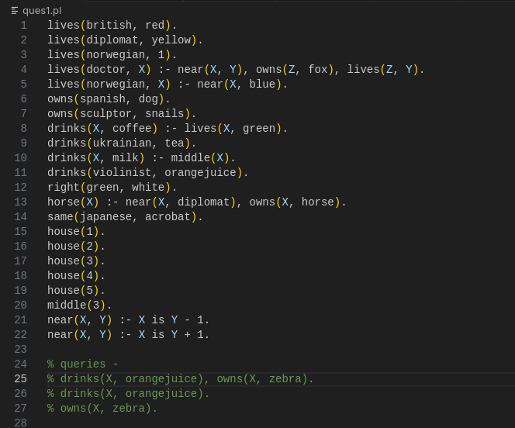

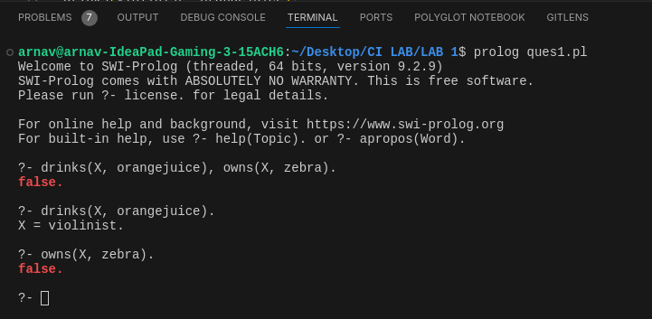results:

Question 2:

code:

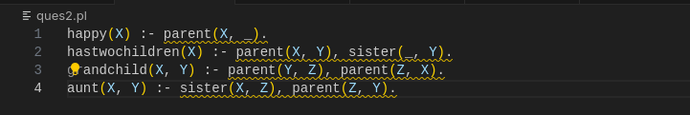

Question 3:

code:

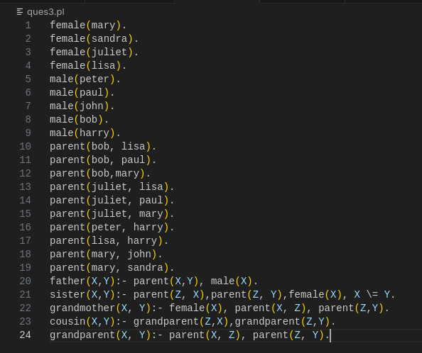

Question 4:

code:

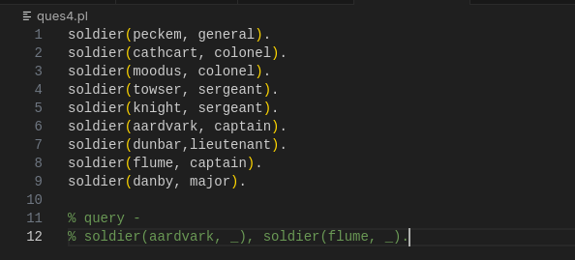

results:

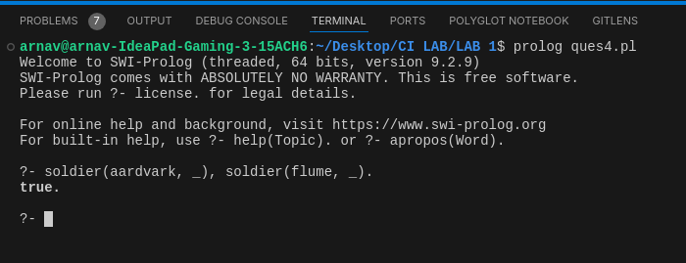

Question 5:

code:

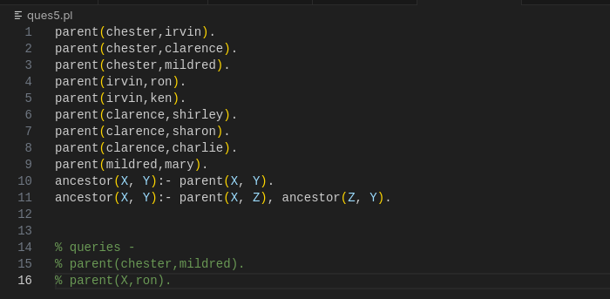

result:

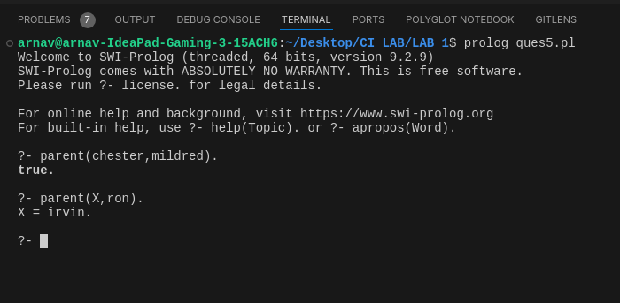

For more details/code files visit here:

<https://github.com/arnavjain2710/Computational-Intelligence-Lab-CS354N/tree/main/LAB 1>